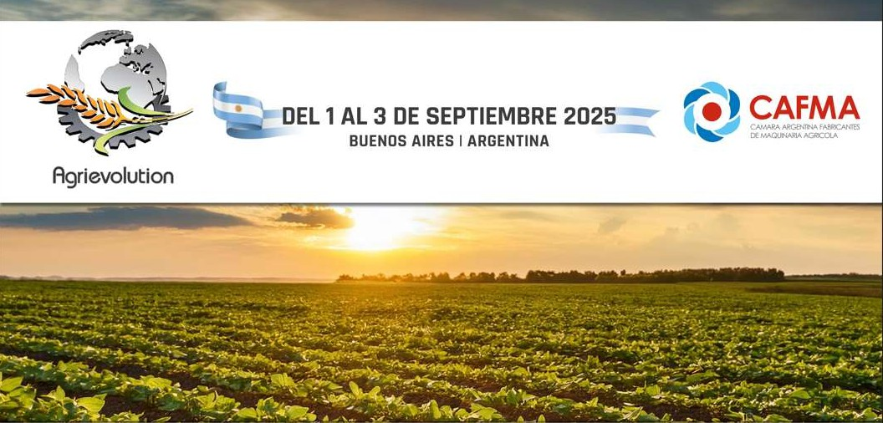
Agrievolution Eighth World Summit on Agriculture:
ACHIEVING FOOD SECURITY and SUSTAINABLE AGRICULTURE thru MECHANIZATION and PRECISION TECHNOLOGIES
September 1-3, 2025 ~ Buenos Aires, Argentina

DAY 1- MONDAY SEPTEMBER 1

9:00-10:00 OPENING AND WELCOME
- Charlie O’Brien, Secretary General, Agrievolution
- Enrique Bertini, President, CAFMA
- Gerardo Werthein, Ministry of Foreign Affairs (invited)
- Sergio Iraeta, Argentina Secretary of Agriculture (invited)
- Daniel Tillard, President, National Bank of Argentina

10:00-10:45 AGRICULTURE CONSERVATION IN ARGENTINA:

EXPERIENCE AND PRACTICE
- Nicolas Bronzovich, President, Argentina National Institute of Agricultural Technology
- Marcelo Torres, President, Argentina No Till Farmers Association (AAPRESID)

Moderator: Ignacio Ruiz, Chair, Agrievolution and Secretary General, National Association for Agricultural, Forestry and Landscaping Machinery (Spain)

10:45-11:15 BREAK

11.15–12:15 SMART FARMING AND AGTECH: IMPROVING PRODUCTION AND ENVIRONMENTAL CONSERVATION
- Kemal Shoshi, President, Representative Director, YANMAR AGRIBUSINESS Co., Ltd.
- Marnix Doorn, Project Manager, Argentine-German Dialogue for Sustainable Agricultural Innovations
- Gustavo Oberto, President, Global Irrigation, Lindsay Corporation
- Konrad Harbort, Founder, Corvus Consulting and German Farmer

Moderator: Curt Blades, Agrievolution Board Member & Senior Vice President, Association of Equipment Manufacturers (USA)

DAY 1- MONDAY SEPTEMBER 1 (continued)

12:15-13:15 LUNCH

13:30-14:30 AGRICULTURE CONSERVATION AND CARBON SEQUESTRATION:
ROLE OF MECHANIZATION
- Miguel Angel Taboada, Specialist, Argentina National Institute of Agricultural Technology (INTA)
- Julián Martínez Quijano, Chair, Argentine Maize and Sorghum Association
- Martin Biscaisaque, Chair, ArgenTrigo
- Joao Morales Soa, Direct Planting, Brazil

Moderator: Ruth Bailey, Agrievolution Board Member and Secretary General, Agricultural Engineers Association (UK)

14.30-16.00 FARMER SUCCESS STORIES FROM AROUND THE WORLD
- Pedro Vigneau, Argentina Farmer: Mechanization/Precision Agriculture in Argentina
- Jorge Lopez Menedez, Farmer in Africa: Need and Opportunity for Mechanization in African Agriculture
- Stefan Cramm, German Farmer and DLG Committee on Farm Management

Moderator: Mary Boote, Agrievolution Strategic Partner and CEO, Global Farmer Network

16.00-16.15 Closing
Charlie O’Brien, Secretary General, Agrievolution

19.30 – 21.00 Gala Dinner

DAY 2 – TUESDAY, SEPTEMBER 2

9:00-9:15 Welcome
Charlie O’Brien, Secretary General, Agrievolution

9.15–10.00 Keynote
Beth Bechdol, Deputy Director General, Food and Agriculture Organization of the United Nations (FAO) (Invited)

10:00-11:00 CHALLENGES OF ACHIEVING GLOBAL FOOD SECURITY
- Beth Bechdol, Deputy Director General, Food and Agriculture Organization of the United Nations (FAO) (Invited)
- Dr. Julio Calzada, Economist, Rosario Stock Exchange (BCR)

Moderator: Alessandro Malavolti, CEO, AMA and President, Agrievolution

DAY 2 - TUESDAY SEPTEMBER 2 (continued)

11:00-11:30 Break

11.30-12:30 SILOBAG SYSTEM STORAGE: A LOGISTIC SOLUTION AND PROFITABLE TOOL
- Ricardo Bartosik, PhD, Researcher & Extension Engineer, Argentina National Institute of Agricultural Technology (INTA)
- Sebastián Calderón, Foreign Trade Manager, Carlos Mainero y Cia
- Lucia Martinez, Director, Martinez y Staneck
Moderator: To be Determined

12:30-13:30 Lunch

13:30-15:00 FUTURE OF AGRICULTURE MECHANIZATION AND PRECISION AGRICULTURE TECHNOLOGIES
- Matteo Vanotti, CEO/Co-Founder, Matteo Cunial, CRO/Co-Founder or Miguel Cordoba, Director of LATAM, xFarm Technologies
- Carlo Lambro, Brand President, New Holland Agriculture
- Andrew Olliver, Chairman, Agriculture Industry Electronics Foundation (AEF) and Global Precision Technology Partner Manager, CNHI
- TR Kesavan, President/CEO, TAFE Ltd.

Moderator: To be Determined

15:00-15:15 CLOSING
- Charlie O’Brien, Secretary General, Agrievolution
- Carlos Braga and Enrique Bertini, CAFMA

15.30 – 17.00 Buenos Aires Tour (optional)

DAY 3 – WEDNESDAY SEPTEMBER 3: FIELD DAY

08:30 BUS DEPARTURE TO FARM FIELD
10:00-12:00 SUSTAINABLE FARMING BEST PRACTICES: Presentation and
Demonstration
12:00-14:00 LUNCH
14:00-16:00 LIVE EQUIPMENT DEMONSTRATIONS
16:30 RETURN TO BUENOS AIRES

5-7-25

